**Cloud:**

Creating a new user

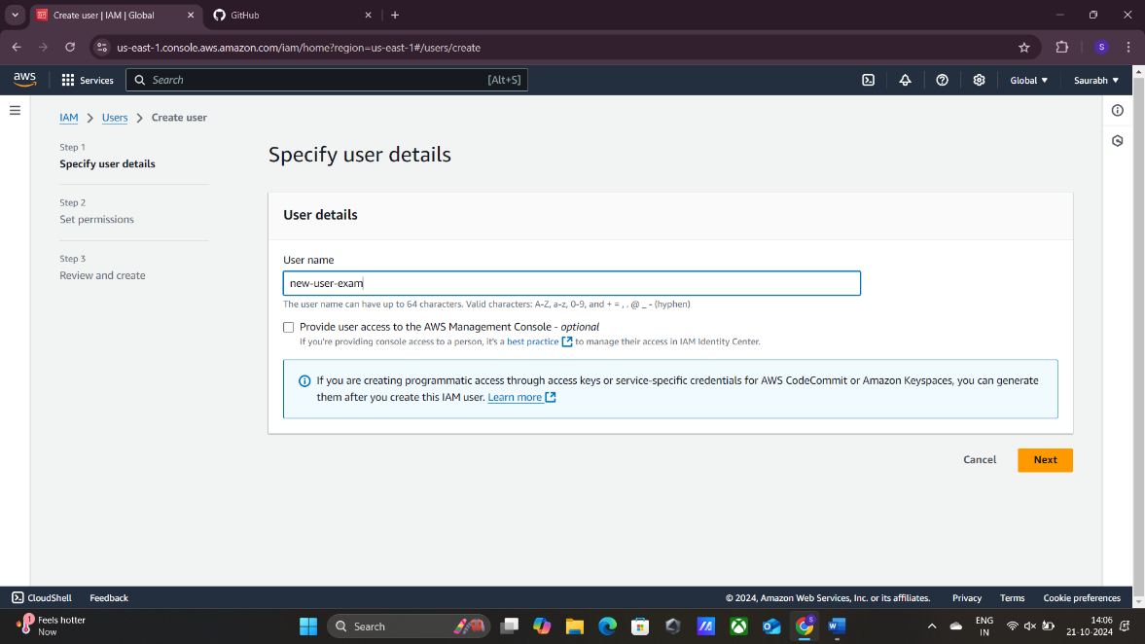

Assigning EC2 full access policy to it

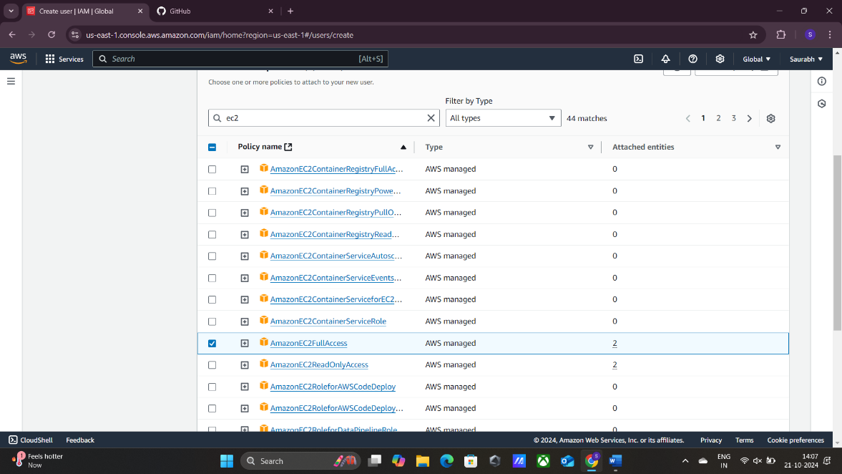

Enabling console access and documenting its credentials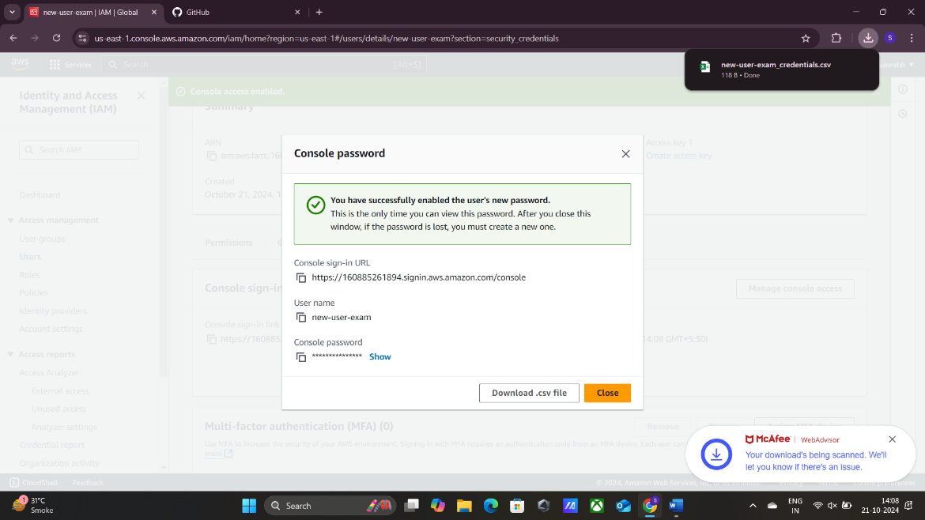

Creating a new access key for that user and documenting it

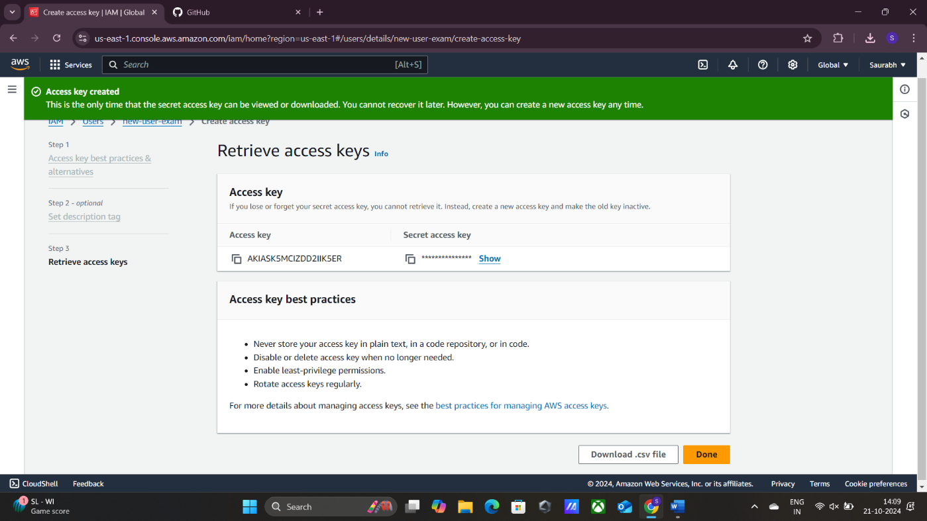

Launching a new instance

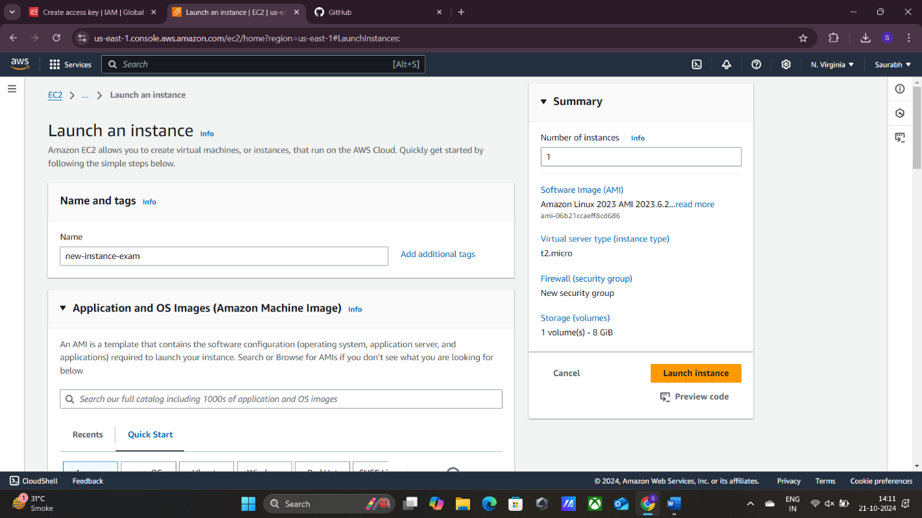

Logging in the new IAM user using the credentials

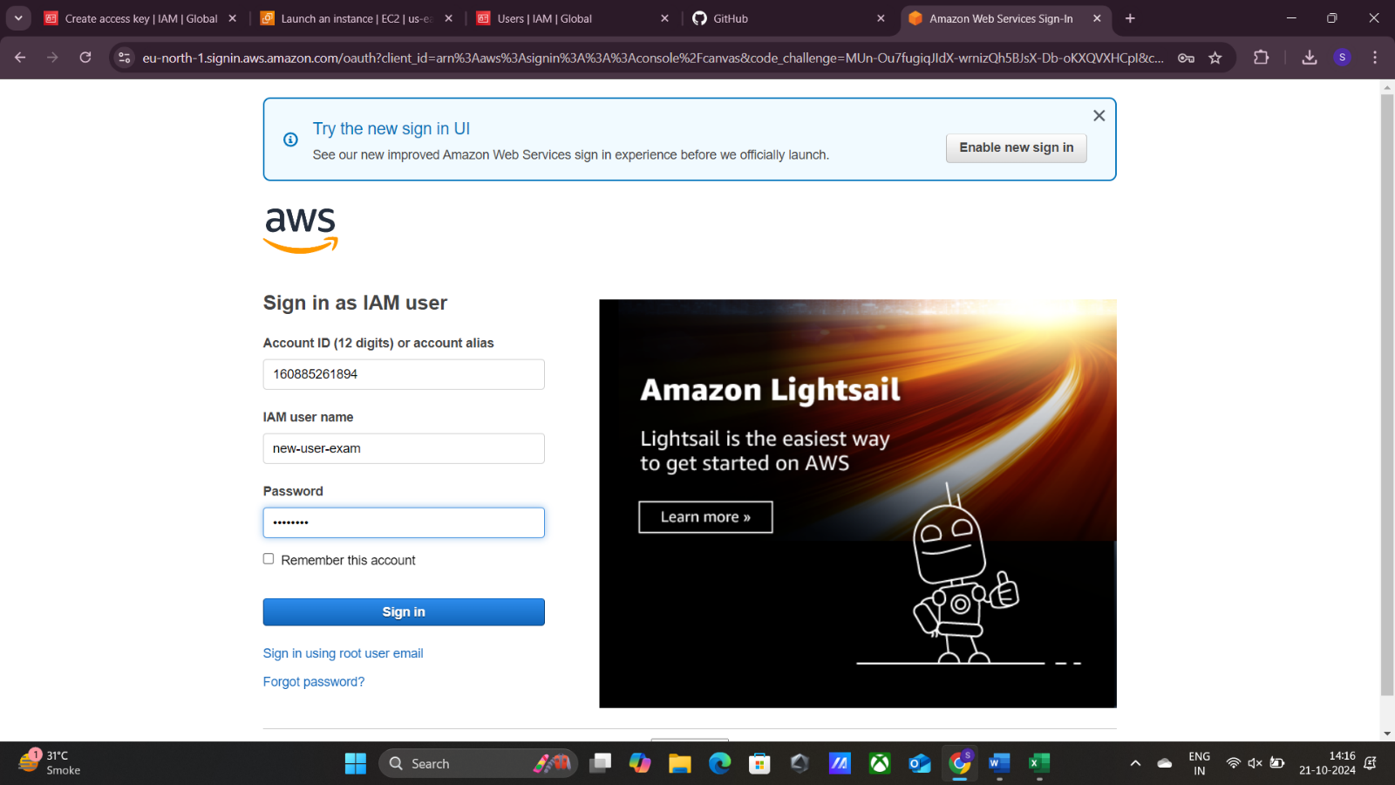

All the instances of the root user are visible to the new IAM user also ,we achieved this by giving full ec2 access to the user while creating it

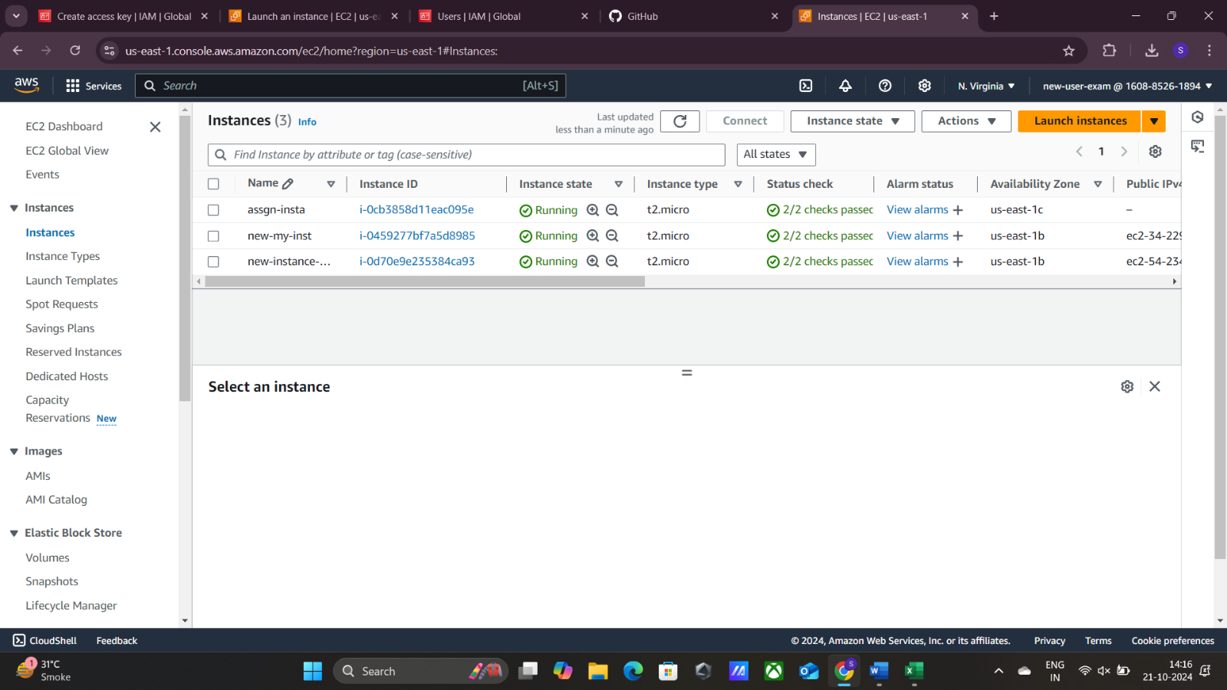

Performing stop operation on the instance that we’ve created

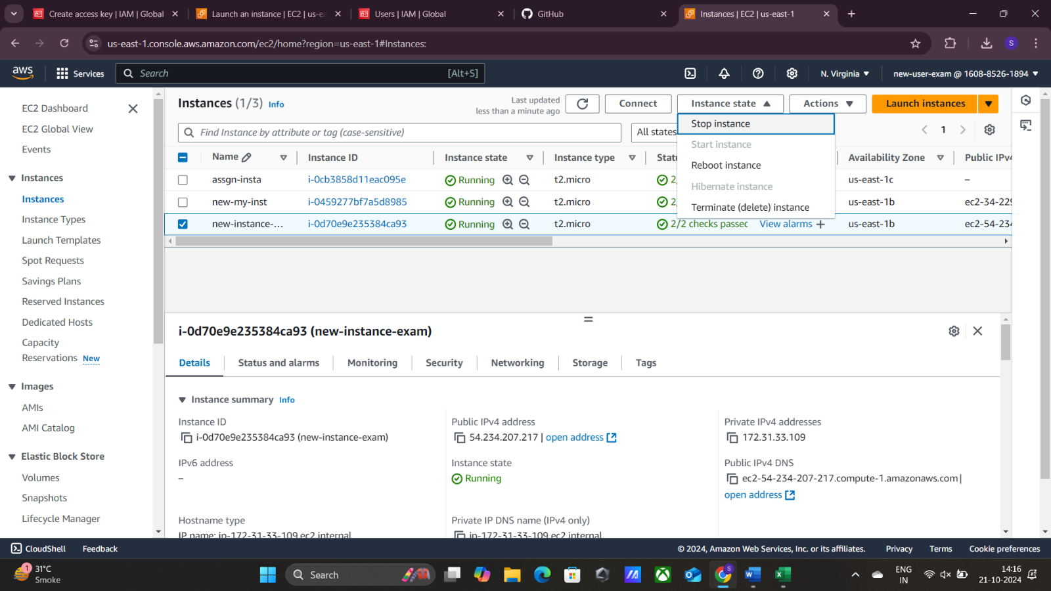

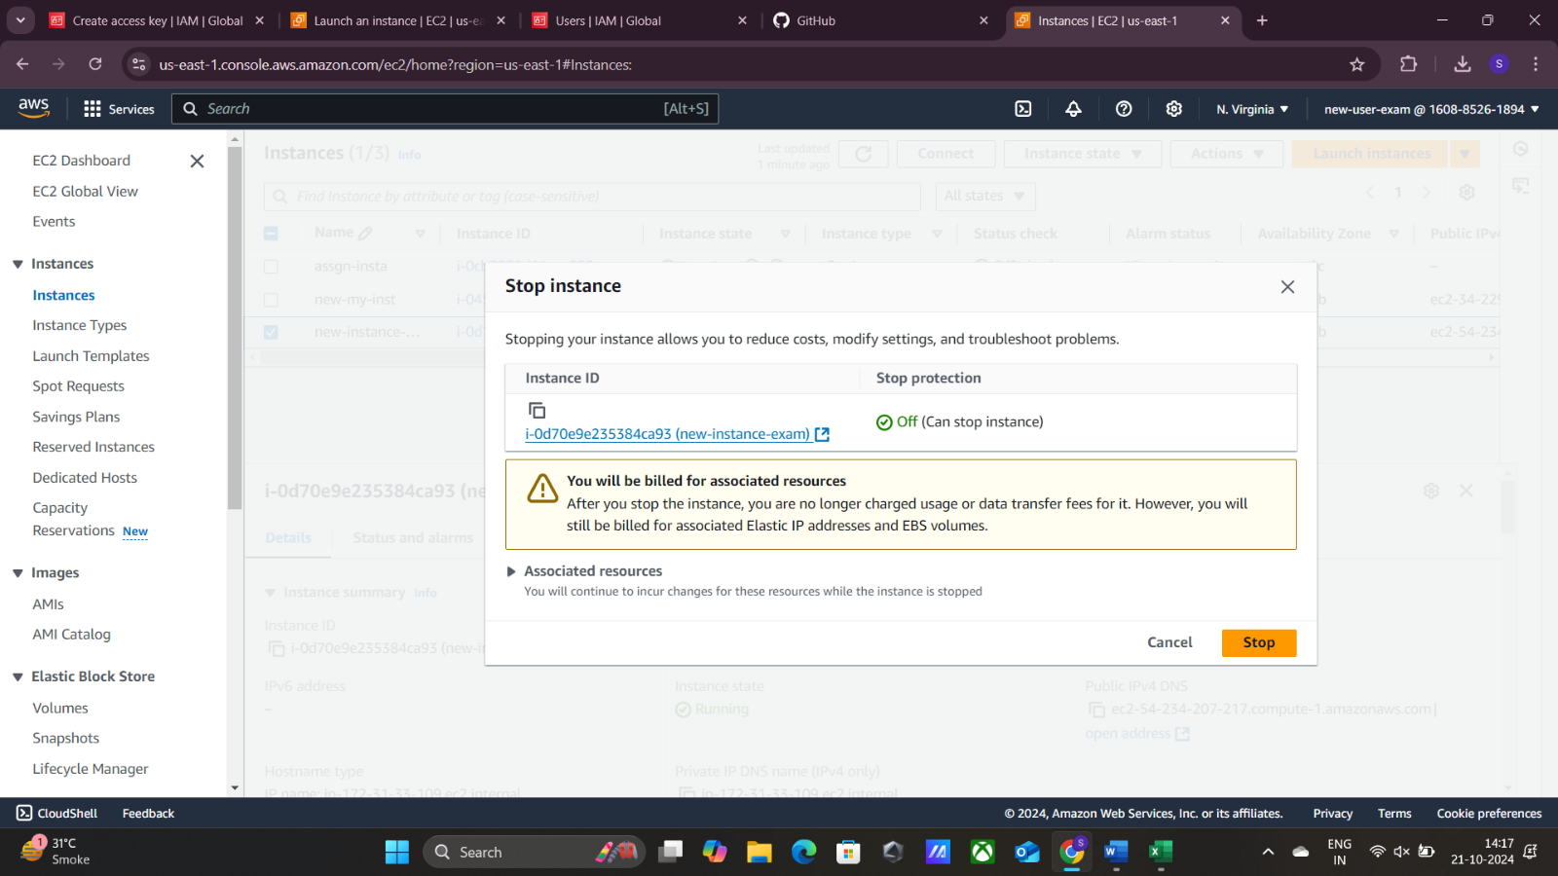

Performing start operation on the instance that we’ve created

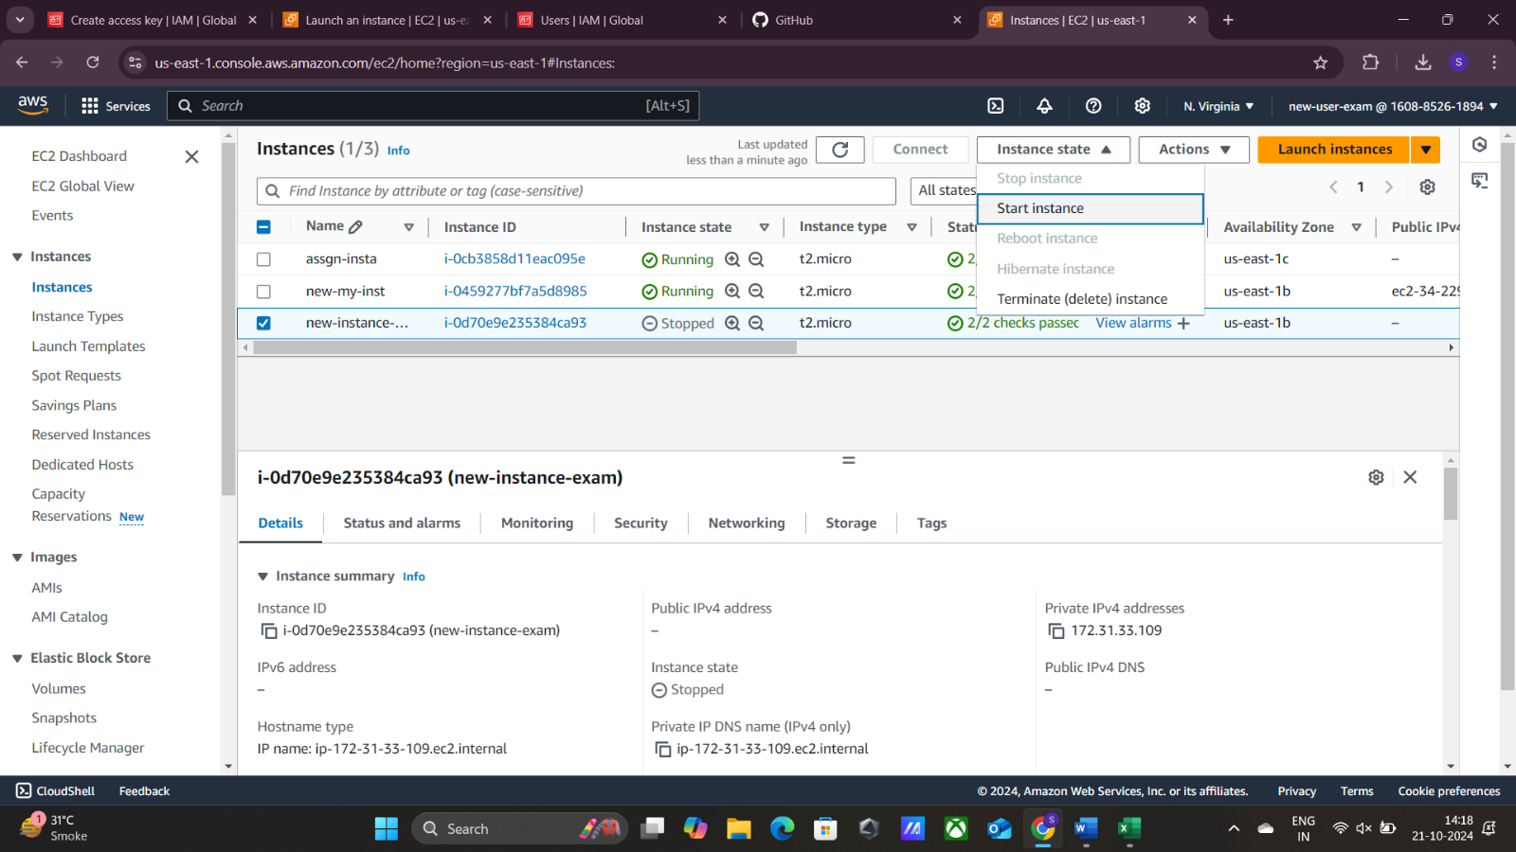

The instance has started and its running

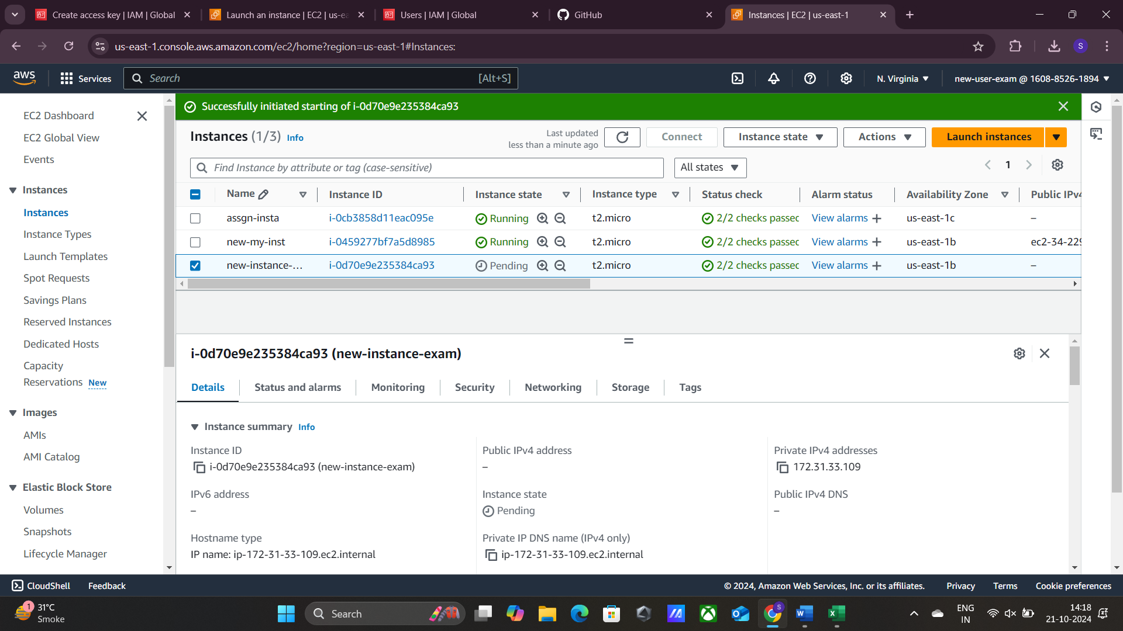

Signing out from the created IAM user and returning to the root user to perform further tasks

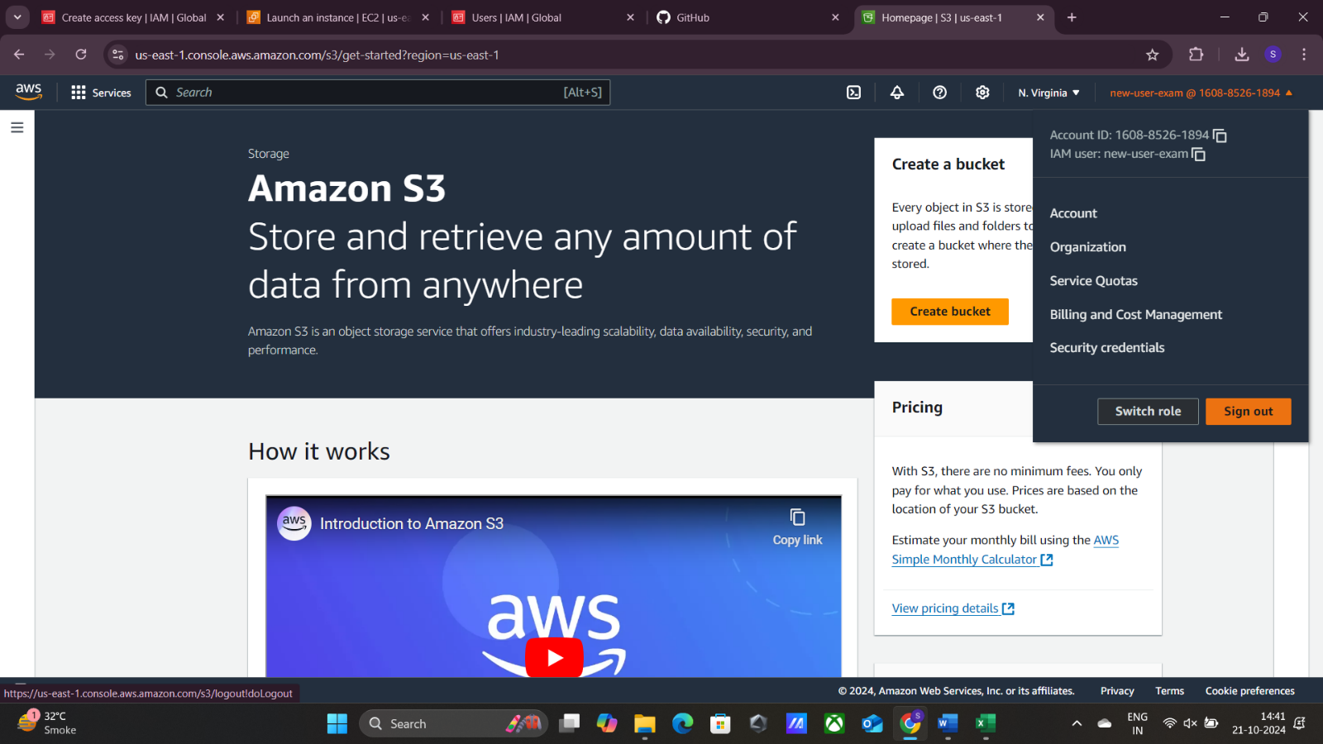

Creating a new bucket in the root user

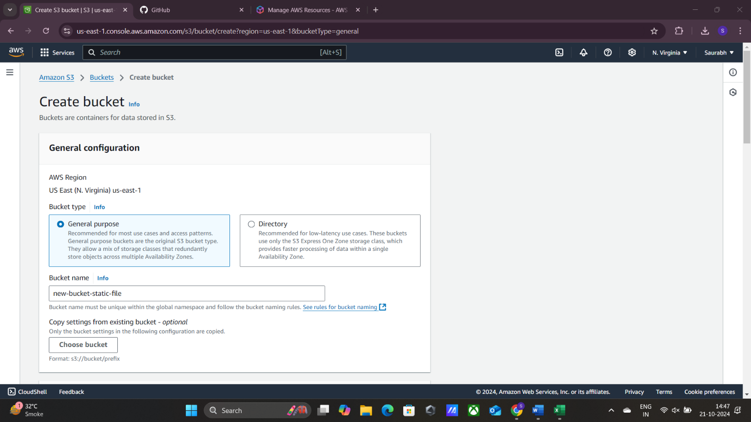

Connecting our ec2 instance through putty by giving public IPv4 address as host name, SSH->Auth🡪credentials🡪 giving our key(.ppk file)

And logging in as ec2-user

Then creating a static file.txt using nano command and assigning “Hello,welcome to my page,” to it

Configuring and accessing our s3 bucket using <aws configure> command

Putting access ID,Key,region name and output format

Now, through command <aws s3 ls> we are able to view all our buckets

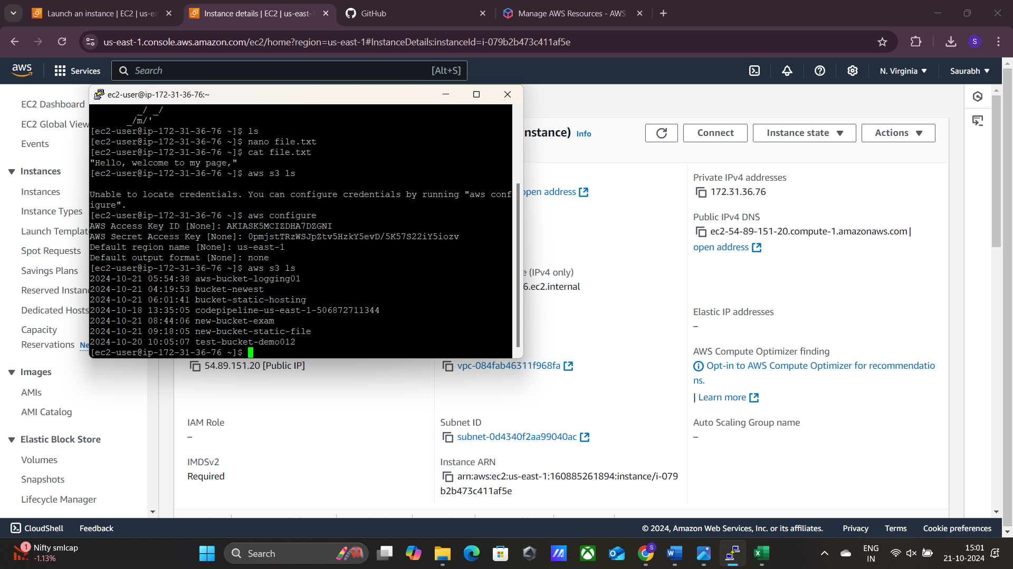

Now through command<aws s3 cp file.txt s3://bucket-name> we upload our file to bucket

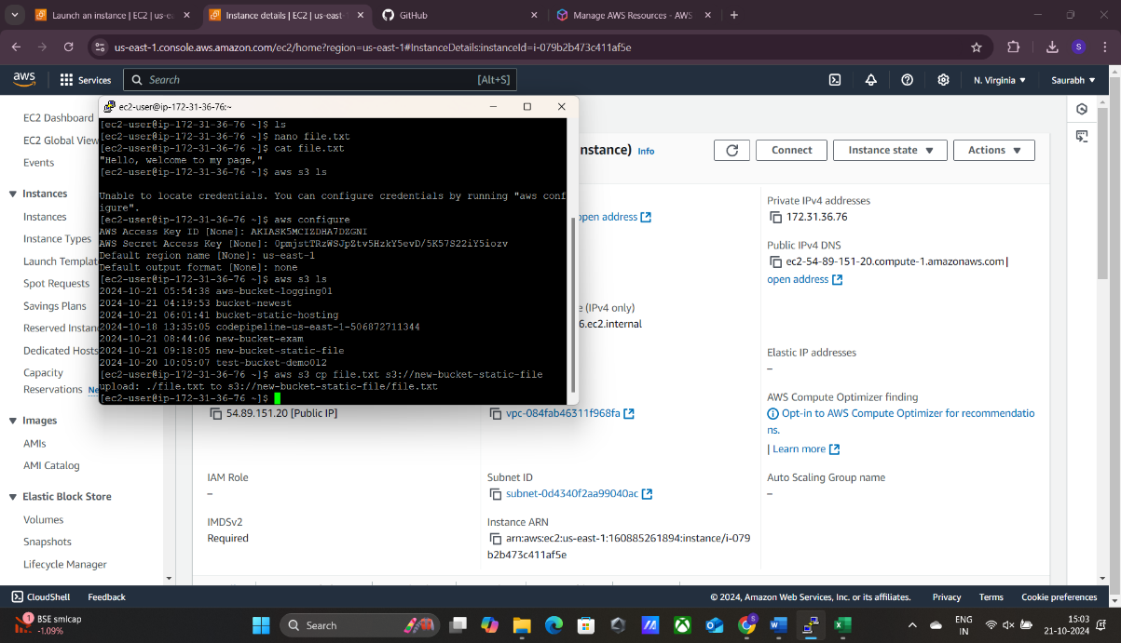

Our file is successfully uploaded to the bucket now

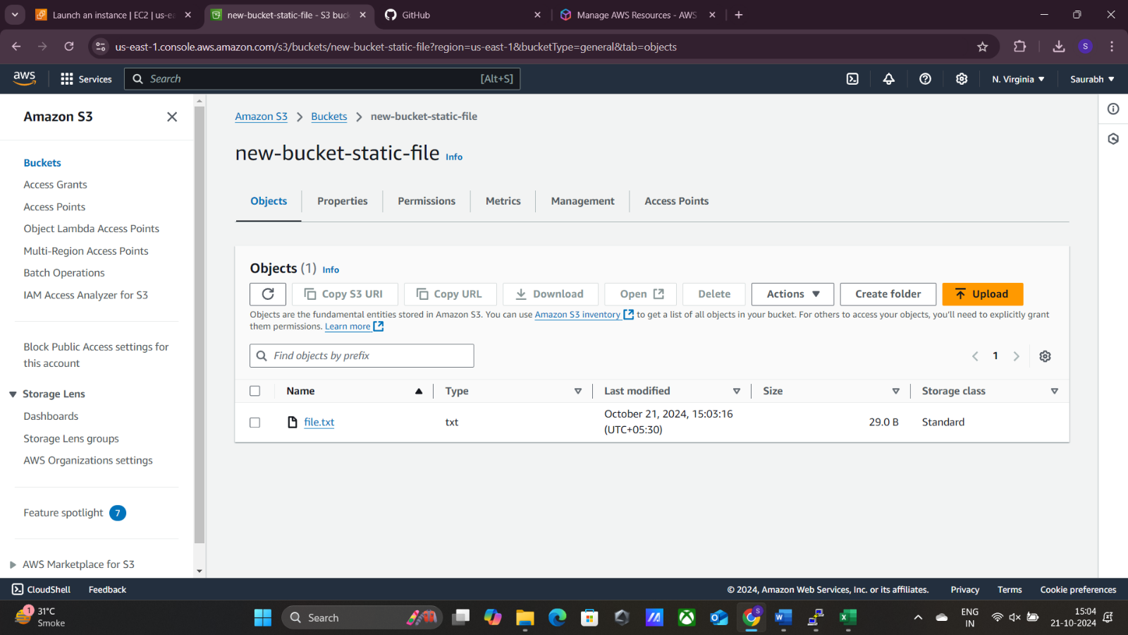

Now, we made our file publicly accessible

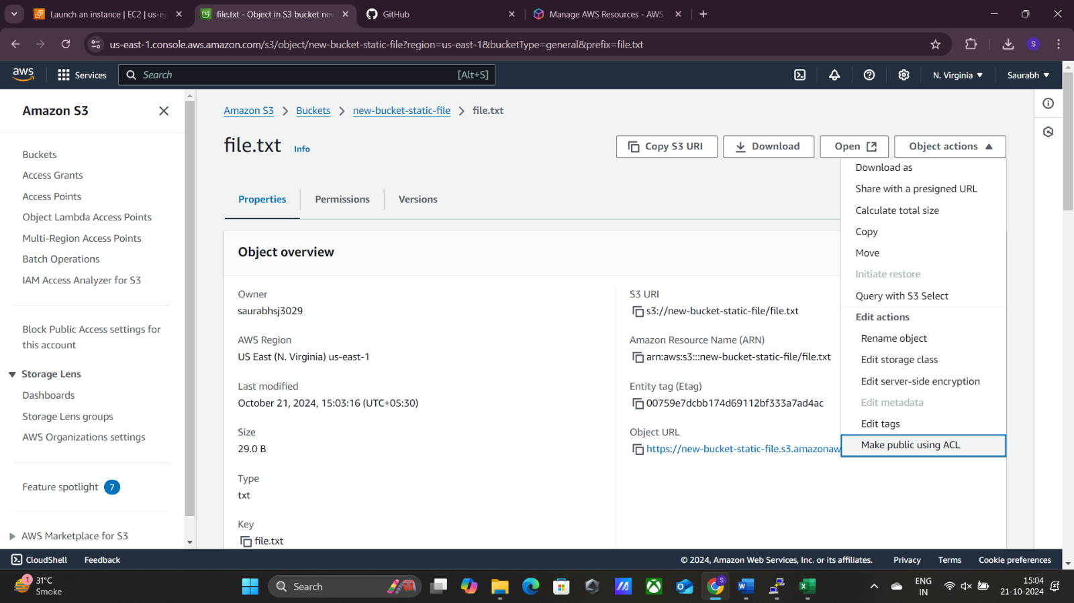

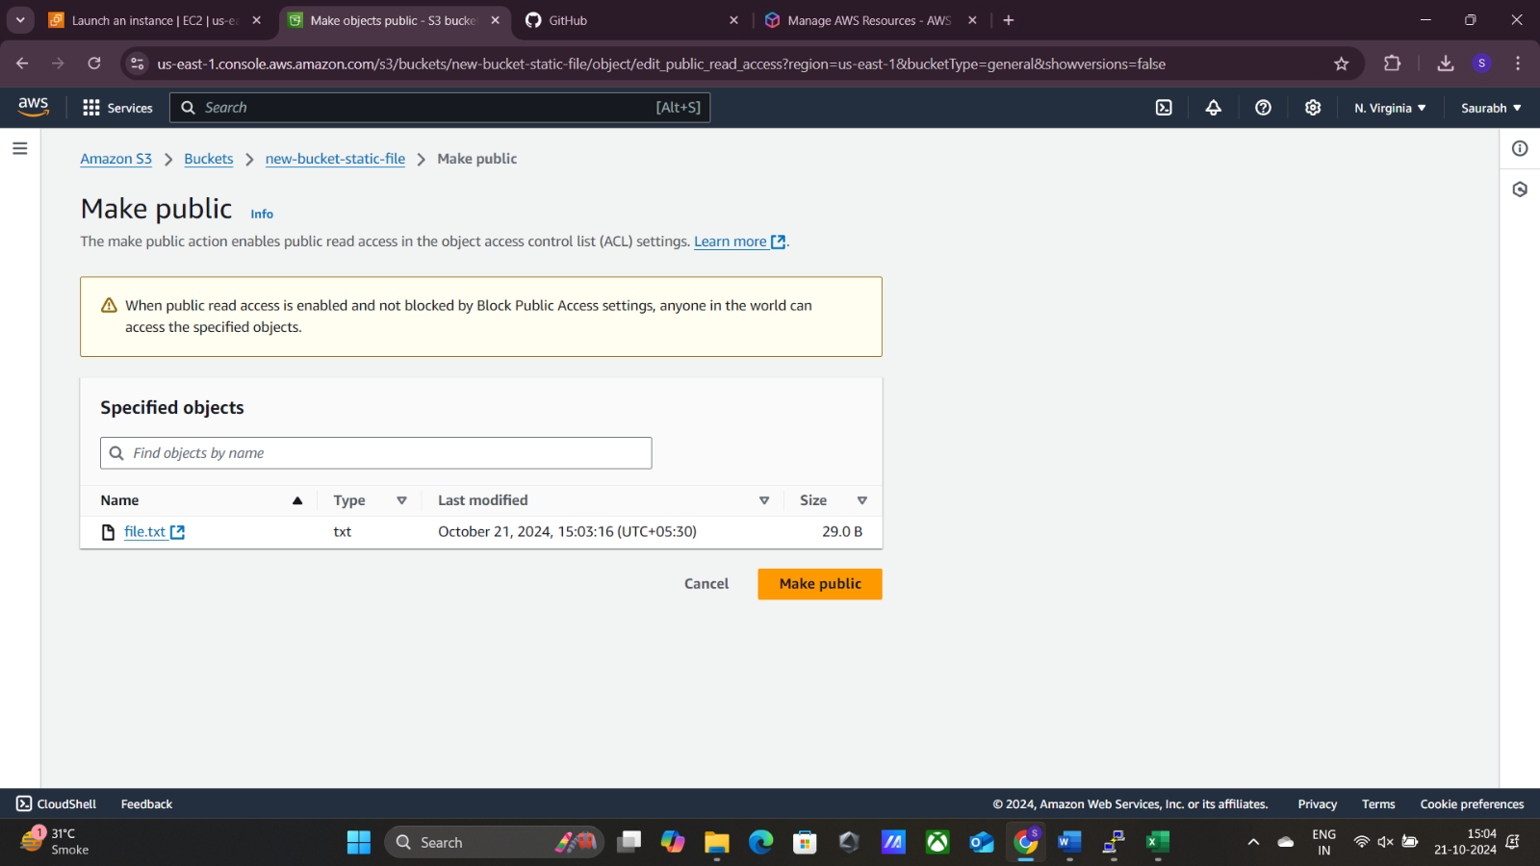

Now, we’ll try to access our static website by its object URL

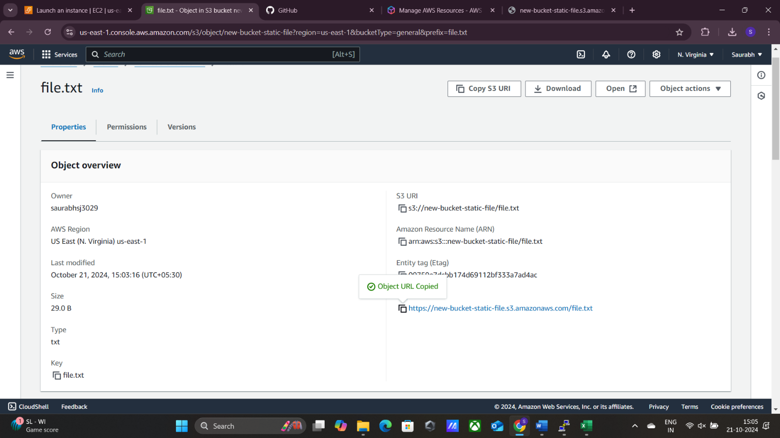

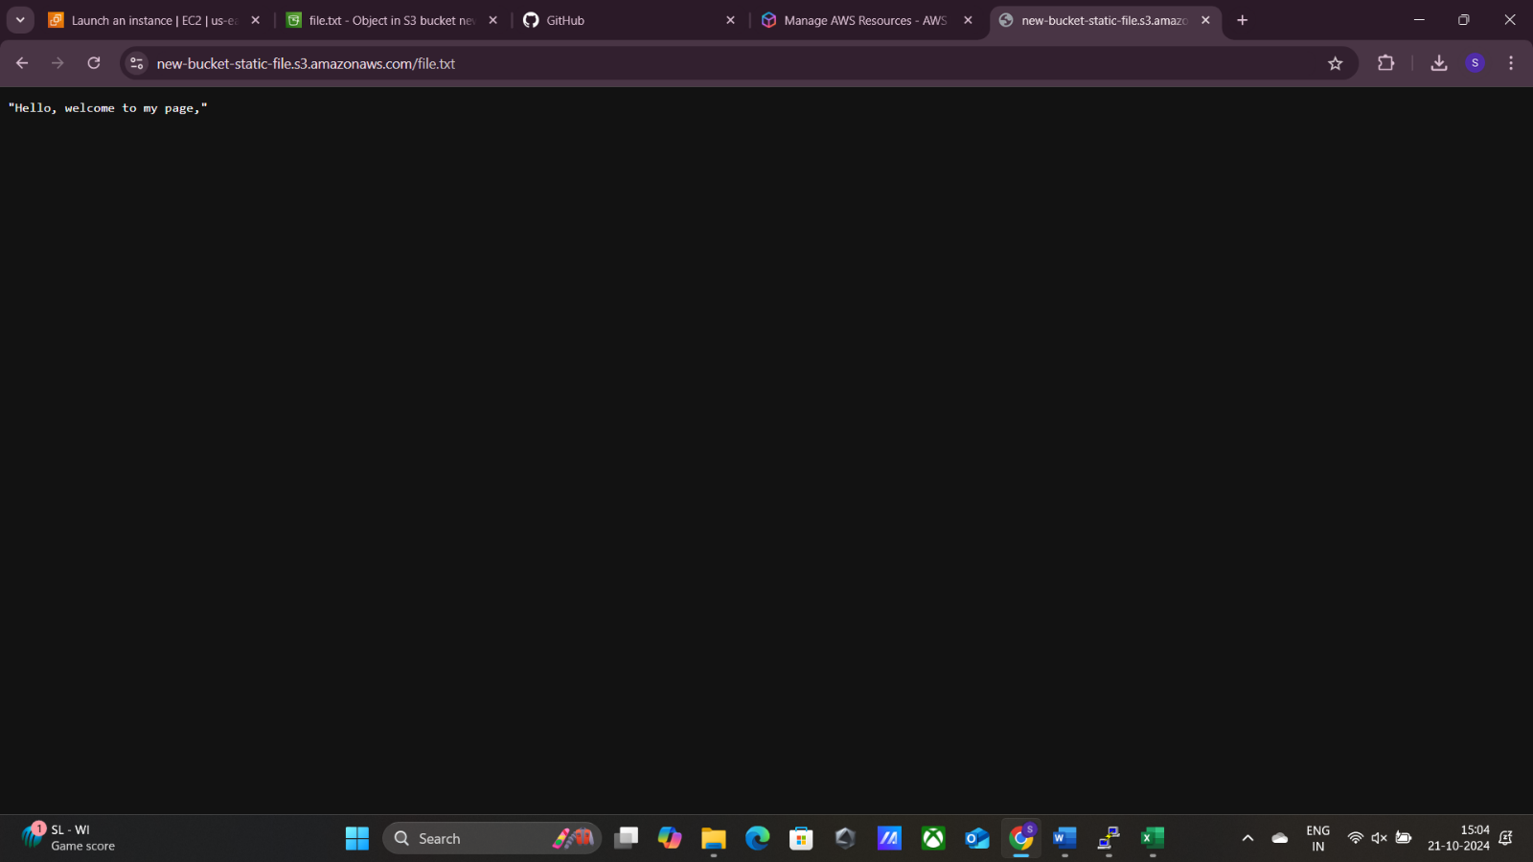

Thus, we have accessed our static website in a browser through it object URL